KS5

Subject | Autumn |  | Spring |  |  | Summer
English | 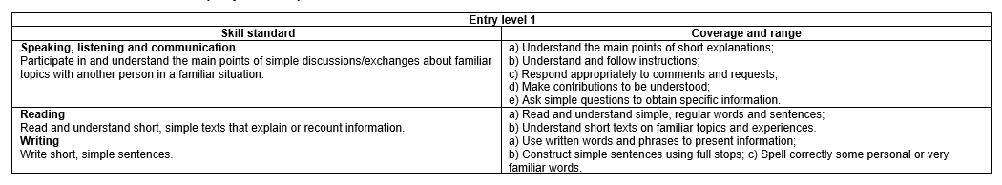  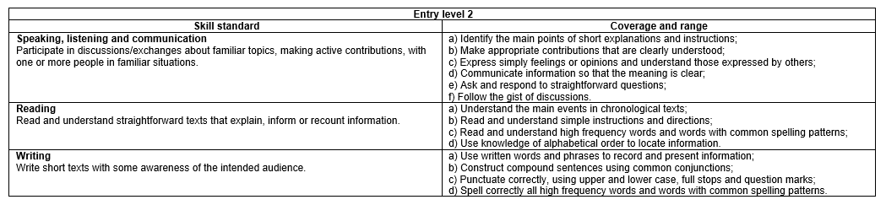  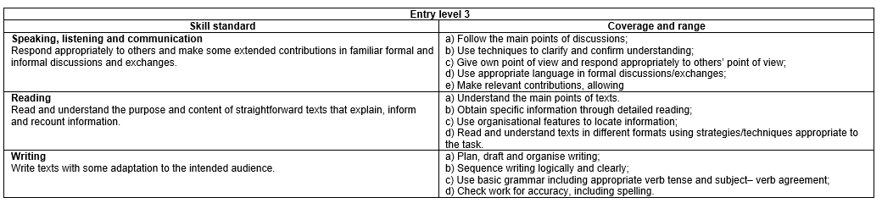  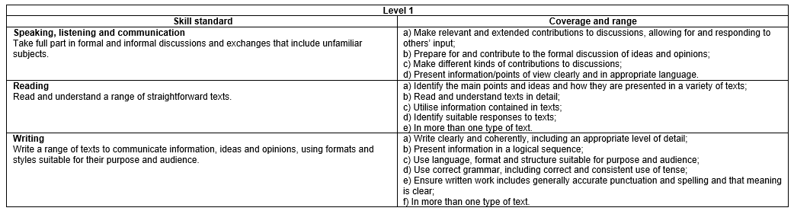
Maths | Autumn |  | Spring |  |  | Summer
Maths | Use numbers and the number system – whole numbers, fractions and decimals |  |  |  |  | Handling information and data  Assessments
  1. Count, read, write, order and compare numbers up to 1000
  2. Add and subtract using three-digit whole numbers
  3. Divide three-digit whole numbers by single and double digit whole numbers and express remainders
  4. Multiply two-digit whole numbers by single and double digit whole numbers
  5. Approximate by rounding numbers less than 1000 to the nearest 10 or 100 and use this rounded answer to check results
  6. Recognise and continue linear sequences of numbers up to 100
  7. Read, write and understand thirds, quarters, fifths and tenths including equivalent forms
  8. Read, write and use decimals up to two decimal places
  9. Recognise and continue sequences that involve decimals
  Use common measures, shape and space
  1. Calculate with money using decimal notation and express money correctly in writing in pounds and pence
  2. Round amounts of money to the nearest £1 or 10p
  3. Read, measure and record time using am and pm
  4. Read time from analogue and 24 hour digital clocks in hours and minutes
  5. Use and compare measures of length, capacity, weight and temperature using metric or imperial units to the nearest labelled or unlabelled division
  6. Compare metric measures of length including millimetres, centimetres, metres and kilometres
  7. Compare measures of weight including grams and kilograms
  8. Compare measures of capacity including millilitres and litres
  9. Use a suitable instrument to measure mass and length
  10. Sort 2-D and 3-D shapes using properties including lines of symmetry, length, right angles, angles including in rectangles and triangles
  11. Use appropriate positional vocabulary to describe position and direction
  1. Extract information from lists, tables, diagrams and charts and create frequency tables
  2. Interpret information, to make comparisons and record changes, from different formats including bar charts and simple line graphs
  3. Organise and represent information in appropriate ways including tables, diagrams, simple line graphs and bar charts
Solving mathematical problems and decision making

• Use given mathematical information including numbers, symbols, simple diagrams and charts;
• Recognise, understand and use simple mathematical terms appropriate to student level
• Use the methods given above to produce, check and present results that make sense to an appropriate level of accuracy; and
• Present results with appropriate and reasoned explanation using numbers, measures, simple diagrams, charts and symbols appropriate to student level.

The context for simple problems at these levels should be familiar to all students.
Digital Literacy | Autumn 1 | Autumn 2 | Spring 1 |  | Spring 2 | Summer 1 | Summer 2
 | Focus:  Being safe and responsible online  Understanding the need to stay safe online refers to examples such as being aware of risks associated with clicking on unknown links or phishing emails, being aware of the evolving nature of such risks, or knowing that devices may be hacked resulting in personal data being compromised or stolen.  • Authentication methods to access devices refers to examples such as strong passwords, fingerprint, facial or voice recognition.  • Minimising the effects of physical stresses refers to examples such as using an adjustable chair, not being too close or too far away from the screen/device and keyboard or mouse.  • Benefits of using security software refers to examples such as preventing, detecting or removing viruses, malware and other threats. | Focus:  Using devices and handling information  Features of a device refers to examples such as the interface required (keyboard or touchscreen) or how a device functions (hand-held, wearable or wireless connectivity). Uses of a device refers to examples such as for making a phone or video call, or sending emails while away from a desk.  • Applications refers to those for desktop, laptop and mobile devices.  • Applying system settings refers to examples such as changing screen brightness, changing speaker volume, or connecting to a Wi-Fi network at work or home.  • Navigating online content refers to using menus, hyperlinks and browser navigation controls such as back and forward buttons or bookmarks.  • Internet searches refers to a specific and clearly defined piece of information or content that might be required in a work or real-life context. | Focus:  Creating and editing  Using a suitable application refers to understanding terminology and concepts relating to documents and media and associated applications, such as word-processed or presentations, with an understanding of the purpose of different applications and typical uses.  • Combining different types of information for a given purpose refers to using text, graphics and images in a work or real-life or context, such as creating a poster or presentation for colleagues. |  | Focus:  Communicating  Online communications refers to short, simple texts using email or other messaging applications. Other digital content refers to graphics, images and videos.  • A video call refers to a one-to-one communication via live video. | Focus:  Transacting  An online form refers to a single page form used to enter information such as registering for or requesting a service, or making an online purchase.  • Personal details refers to name, address, telephone number, email address and payment details.  • Data validation refers to automatic computer checks to ensure that data is entered correctly, such as password requirements or key fields that cannot be left blank.  • Verification checks refers to a check carried out to ensure the user has entered their details accurately, such as following a link in an email received when setting up an online account. | Focus:  Assessment and project
PSHE | 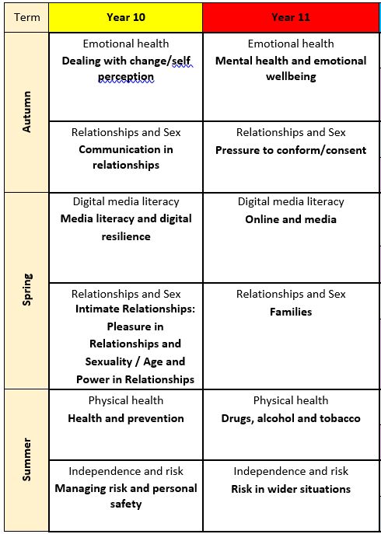
Options | All Key stage 4 and 5 students are timetabled Options on a weekly basis. Each student engages in an option, which runs for half a term.  The aim of the option choices is to introduce ideas and skills that they may use to further their education at another college.  Textiles - Allowing the students to explore and work with various materials. Planning a project, cutting out and creating the finished product, using different mediums.  Performing Arts - The students will work within all aspects of this subject, creating drama pieces, play musical instruments and sing.  Film Studies - As a group the students will watch a film, analyse characters, settings and genres. Prompting discussions and debates.  Sports Leaders - Individually and as a group, the students will learn how to support and coach a small group in various areas of sport.  Childcare - Students will learn how children develop through the stages from birth to pre-school. Understanding how they learn through play, what toys and games they play with at each stage. Learning what you need to look after a baby/ toddler.  Robotics - Using computers and I-Pads the students will be exploring how to build and program working models.  Finances - Each student will be learning about finances, how to budget and understanding bank statements/ wage slips.  Gardening - Students will learn how to prepare the ground for planting, grow seedlings, planting out and harvest the fruits of their labour.  Food Tech - Students will continue to learn a healthy eating curriculum, enhancing their current skills. Enabling them to be confident in the preparation of food independently.
Enrichment | All Key stage 4 and 5 students are timetabled an Enrichment opportunity on a weekly basis. Each student engages in a variety of activities structured termly. The overall goal is to introduce new ideas to the students that they may develop an interest out of college or take up as a hobby, becoming part of a wider community, developing relationships and making new friends  Walking - The students will learn how to access the local community, planning routes and gain road safety knowledge.  Science- Students will be visiting Hurst College on a weekly basis to engage in a program of Science activities. They will be acquiring transition skills by familiarising themselves with a new environment and unfamiliar people.  DT -Each student will be preparing, planning and creating pieces towards the Jim Green competition, which is held annually at Ardingly showground. A great opportunity for the students to mix with other colleges.  Art - All students will learn how to create a variety of art, using different media.  Sport - Students will be visiting Hurst College on a weekly basis to engage in a program of Sport activities. They will be acquiring transition skills by familiarising themselves with a new environment and unfamiliar people.  Radio - The students are learning media skills, with new, unfamiliar equipment to enable them to produce podcasts and radio interviews. They will also visit to a local radio station to gain knowledge of a working environment.  Virtual reality - A completely new experience for the students, each will learn how to use the new VR equipment to create an immersive film.  Healthy Eating - Following a healthy eating program, students will learn how to budget, prepare and cook a variety of breakfasts, snacks and meals.  Model making - Each student will learn how to create a model, using a variety of different media.  Performing Arts - Students will be visiting Hurst College on a weekly basis to engage in a program of performing arts. They will be acquiring transition skills by familiarising themselves with a new environment and unfamiliar people.  Stories and activities - PMLD and SLD students will be engaging in a variety of stories and related activities, to include drama, art and sensory.  List of current clubs on offer. Change during year to meet the needs of the students and change of season.
Reading | Focus on building students’ motivation to read, to give purpose and to activate and expand schema;  - Raising awareness of how to access as variety of reading materials  - Modelling and supporting the selection of appropriate reading material  - Modelling the benefits of being a reader |  |  | Focus on the mechanics of reading;  - Text comprehension  - Developing fluency  - Extending vocabulary |  | Focus on evaluation of the text;  - Characters, setting and plot development  - Style of writing and presentation  - Choice of language  - Comparison to other books by the same author/other books in the same genre
Communication | The development of functional communication skills for our pupils is perhaps, the most important thing that they will learn in their time with us. Having effective methods of communication allows our children to recognise, identify and express feelings, needs and wants.  Woodlands Meed embraces a Total Communication environment that involves using and accepting all types of communication equally.  Regular scheduled sessions allow staff to  - Identify and support a child’s means or mode of communication.  - Motivate a child by providing a reason for him/her to communicate.  - Practise and create opportunities to communicate  - Develop social skills in preparation for adulthood  In weekly scheduled sessions - the wide ranging approaches to communication that our pupils use, can be practised in individual and group situations in familiar settings with familiar staff; we are happy to share these approaches with parents and carers.  They may include: Attention Autism, Pictures Exchange Communication, Objects of reference, AAC use and Makaton signing.  For the further development of social skills for our verbal learners the Talkabout programme includes:  - Developing Self-Awareness and Self-Esteem  - Developing Social Skills  - Developing Friendship Skills  - Building Self-Esteem and Relationship Skills  - Developing Social and Emotional Communication Skills  Transitions: From Education to Employment
PSD | The PSHE programme for WMC is non-accredited but offers an opportunity to educate and support learners’ knowledge and understanding of themselves, their communities and the wider world. Although a LTP has been created Class Teachers are best placed to understand the needs of their students and can and should deviate from the plan. It also offers an excellent opportunity for students to settle into the college day, to have allocated time to focus and reflect on their Next Step targets engaging students with the process with the aim of them to have greater ownership of them. Where appropriate, it would offer time for mentoring/1.1 to take place. It will provide invaluable to support learners to prepare for annual review process.
Skills review | All Key stage 4 and 5 pupils are timetabled weekly skills review sessions. A student ‘skills review’ with their class teacher is an important process for both the student and the class teacher. It allows the student to provide feedback on their learning and helps the teachers assess their progress and make any necessary changes. It provides invaluable time to support learners to prepare for key events throughout the academic year and reflect on their targets. The skills review also offers an opportunity to capture learner’s voice and to celebrate pupil’s achievements.
Travel training | Our Travel Training Programme is designed to teach pupils, the skills and knowledge necessary to travel independently and safely using public transportation or other means. This kind of programme aims to increase the individual's mobility and overall independence, enabling them to access education, employment, and community resources more effectively.  Students will learn to access and use various amenities in the local community. The students will make choices and communicate their preference of places to visit. They will use different forms of transport to travel to these places. The transport may include walking, bus or train.

